QUESTION #1:

#include <math.h>
#include <stdio.h>

int
main (void)
{

double numone;
printf("What is your first number?\n"); /* asks user for first number */
scanf("%lf", &numone);

double numtwo;
printf("\nWhat is your second number?\n"); /* asks user for second number */
scanf("%lf", &numtwo);

double numthree;
printf("\nWhat is your third number?\n"); /* asks user for third number */
scanf("%lf", &numthree);

double arr[] = {numone, numtwo, numthree};

double min = arr[0];
double med = arr[0];
double hi = arr[0];

for (int i = 0; i < 3; i++) { /* for statement to find lowest number*/
if(arr[i] < min) {
min = arr[i];
}
}

for (int j = 0; j < 3; j++) { /* for statement to find highest number*/
if(arr[j] > hi) {
hi = arr[j];
}
}
for (int k = 0; k < 3; k++) { /* for statement to find middle number*/
if(arr[k] < hi & arr[k] > min) {
med = arr[k];
}
}

printf("\nThe highest value is %.0lf", hi);
printf("\nThe middle value is %.0lf", med);
printf("\nThe lowest value is %.0lf", min);
}

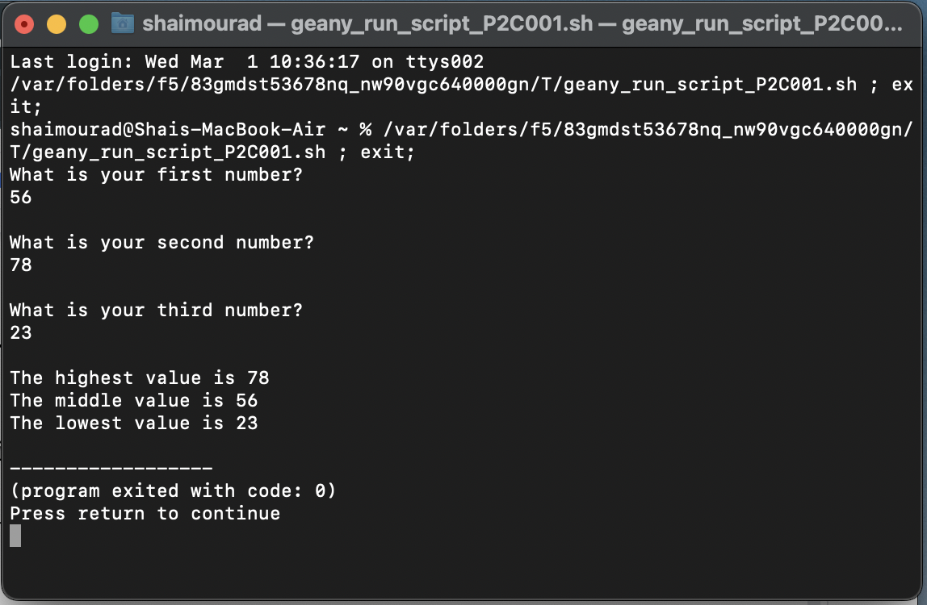

QUESTION #2:

#include <math.h>
#include <stdio.h>
#include <string.h>

int
main (void) {

char place[20];
double prigee;
double apogee;
double speed;
double atime;
double ptime;

while (strcmp (place, "Exit") != 0) {

if (strcmp (place, "Exit") != 0) {
printf("\nWhere are you going? (enter Moon, Mars, Venus or Exit)\n"); /* asks user for where they are going */
}

scanf(" %[^\n]",place);
getchar();

if (strcmp (place, "Moon") == 0) { /* Moon scenario */

printf("How fast are you going in km/h?\n"); /* asks user for speed */
scanf("%lf", &speed);

prigee = 363104;
apogee = 405696;

ptime = prigee/speed; /* calculating the maximum and minmum time required */
atime = apogee/speed;

printf("The minmum time to the %s is %.2lf hours \n", place, ptime);
printf("The maximum time to the %s is %.2lf hours \n\n", place, atime);

strcpy(place, "");

}
if (strcmp (place, "Mars") == 0) { /* Mars scenario */

printf("How fast are you going in km/h?\n"); /* asks user for speed */
scanf("%lf", &speed);

prigee = 54600000;
apogee = 401000000;

ptime = prigee/speed; /* calculating the maximum and minmum time required */
atime = apogee/speed;

printf("The minmum time to the %s is %.2lf hours \n", place, ptime);
printf("The maximum time to the %s is %.2lf hours \n\n", place, atime);

strcpy(place, "");

}
if (strcmp (place, "Venus") == 0) { /* Venus scenario */

printf("How fast are you going in km/h?\n"); /* asks user for speed */
scanf("%lf", &speed);

prigee = 38000000;
apogee = 261000000;

ptime = prigee/speed; /* calculating the maximum and minmum time required */
atime = apogee/speed;

printf("The minmum time to the %s is %.2lf hours \n", place, ptime);
printf("The maximum time to the %s is %.2lf hours \n\n", place, atime);

strcpy(place, "");
}

if (strcmp (place, "Exit") == 0) { /* Exit scenario */

printf("\nYou have successfully exited the program.\n");
return(0);
}
}
}

